Homework Problem Set 6: Data Modeling

# Overview

In this lab, we will explore how to capture entity-relationship data requirements and make crow’s foot entity-relationship diagrams.

## Learning Objectives

Upon completion of the lab, you should be able to:

* Clearly identify the benefits of conceptual data modeling.
* Explain the difference between conceptual and logical modeling.
* Capture data requirements as entities, attributes, and relationships.
* Check E-R models for weak and associative entities.
* Use a diagramming tool such as **Draw.io** to draw E-R and relational model diagrams.
* Map conceptual models to logical model by following mapping rules and best practices.

## What You Will Need

To complete this lab, you will need the Draw.io tool by <https://www.diagrams.net/>. You can draw your diagrams online or download the app to your computer. Follow the link to draw in the browser or download.

# Walkthrough

## Step 1a: Conceptual: Learn to Use Draw.io

Watch this video to get started drawing conceptual model diagrams with the **Draw.io** tool. The video will take you through the basics of setting up entities, relationships, and attributes:

<https://youtu.be/7lGFx-qYmhU>

Also, here is more general tutorial for how to use Draw.io here: <https://www.youtube.com/watch?v=Z0D96ZikMkc>

## Step 1b: Recreate an ERD From a conceptual model

After you have completed the tutorial, try to draw this diagram by recreating it exactly: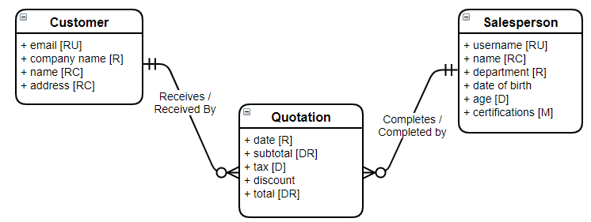

When you are done, save the diagram file as **sales-quotation**.

## Step 1c: Logical Models: Learn to Use Draw.io

Watch this video to get started drawing logical model diagrams with the **Draw.io** tool. The video will take you through the basics of setting up tables, columns annotations, and foreign keys.

<https://youtu.be/CmjW3HyazRA>

## Step 1d: Recreate This Logical Model

After you have completed the tutorial, try to draw this diagram by recreating it exactly:

When you are done, save the diagram file as **customer-addresses**.

# Walkthrough

## Step 2a: Drawing an ERD From E-R Requirements.

Now that you are comfortable drawing a conceptual and logical model diagrams, it’s time to learn how to draw them from requirements and map conceptual models to logical models.   
  
Try to draw a crow’s foot ERD from the following E-R requirements. You must turn the requirements into the correct diagram.

1. Entities: **Foo, Bar, Baz, Qux**
2. Attributes:
   1. **Foo:** flip (required), flop (unique)
   2. **Bar:** beep (required and unique), bloop (multivalued)
   3. **Baz:** zoop (composite, required), zip, zap (unique)
   4. **Qux:** quick (required, unique), quack, quote
3. Relationships:
   1. A **Foo** gobbles 1 or more **Bar**. A **Bar** is gobbled by 0 or more **Foo**.
   2. A **Foo** quaffs 1 and only 1 **Qux**, but a **Qux** can be quaffed by 1 or more **Foo**.
   3. A **Bar** guzzles 0 or more **Baz**, a **Baz** is guzzled by 0 or more **Bar**. Furthermore, when a Bar or Baz is guzzled there are attributes: guzzle-amount (required) and guzzle-date (required).

When you are done save the diagram as **foo-bar-baz**.

## Step 2b: Identifying E-R Data Requirements, Then Draw an ERD

Normally we are not given such specific requirements. We are usually just given information about the system we are designing, and then it’s up to us to:

1. Identify the E-R requirements
2. Draw the ERD

In this final step, practice capturing the E-R requirements and then draw the ERD.

**Information Provided**:  
Spotify is an online music streaming service. Spotify has over 10 million songs containing information such as title, artist, which of many genres the music belongs to, and length of song. Users sign up for the service providing their name, email, and option list of music genres they prefer. Users can build playlists of songs. These playlists are built from individual song titles, and Spotify keeps track of when the playlist was created. In addition, any song listened to is archived to a history table so that the company can do analytics on the songs users are listening to and credit artists.

Identify the E-R requirements:

1. Entities: Object data
2. Attributes: Atomic values for each entity, include properties such as required, unique, and so on
3. Relationships: Business rules among the entities, including cardinality in both directions

Use a copy of the **Empty-ER-Data-Requirements** spreadsheet, provided with this lab, to enter your data requirements.

After you identify the requirements, draw the diagram, and save the diagram as **Spotify**.

## Step 2c: Mapping a Conceptual Model to a Logical Model

Try to map this conceptual model to a logical model in relational notation. Follow the mapping rules we learned in this unit as they apply to entities, relationships, and attributes.

After you identify the requirements, draw the diagram, save the diagram as **rideshare**.

## Step 2d: Mapping a Conceptual Model to a Logical Model

Map the following conceptual model to a logical model drawn as a relational diagram. Save the diagram as **quotation**.

After you identify the requirements, draw the diagram, and save the diagram as **quotation**.

# Questions

Answer these questions using the problem set submission template. You will need to provide a screen shot for each answer. Please follow the guidelines for submitting a screen shot.

1. Provide a screen shot of your completed E-R diagram, **sales-quotation**.
2. Provide a screen shot of your logical model, **customer-addresses**.
3. Provide a screen shot of your completed E-R diagram, **foo-bar-baz**.
4. Provide the data requirements for **Spotify**.
5. Provide a screen shot of your drawn E-R diagram, **spotify**,as drawn from your requirements.
6. Provide a screen shot of your relational diagram, **rideshare**, as drawn based on your mapping from the E-R conceptual model.
7. Provide a screen shot of your relational diagram, **quotation**, as drawn based on your mapping from the E-R conceptual model.